nēhiyāw masināhikan

Cree Language Booklet



**Unit 3**

**Animals/Actions**

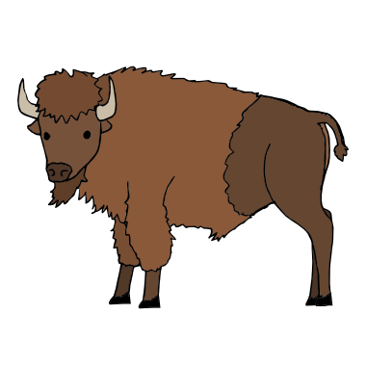

**paskwāw mostos**

**puss-kwaaw mush-tush**

**buffalo/bison**

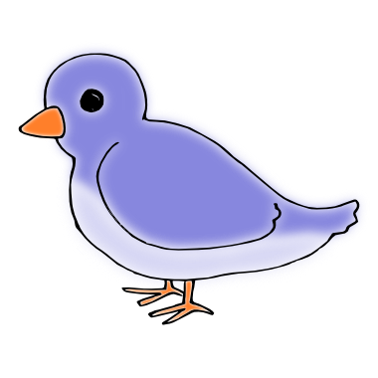

**piyesis**

**pee-yeh-sheesh**

**bird**

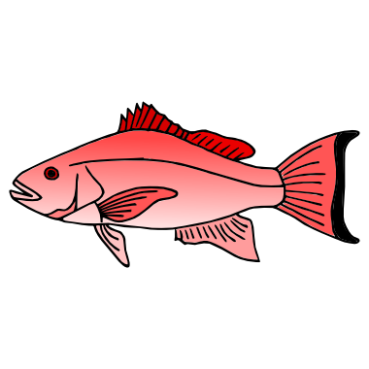

**kinosew**

**kin-oh-seew**

**fish**

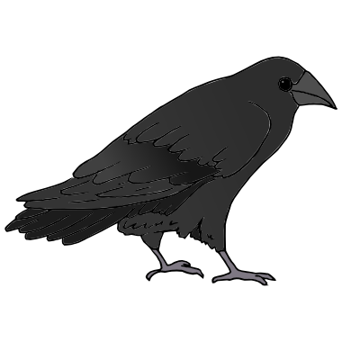

**kāhkākiw**

**kaah-kaah-keew**

**Raven**

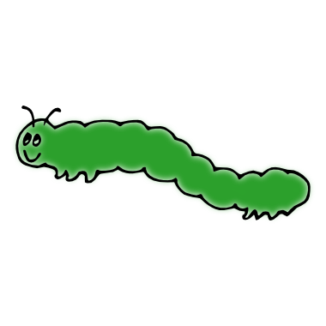

**mohtew**

**mooh-teew**

**Worm**

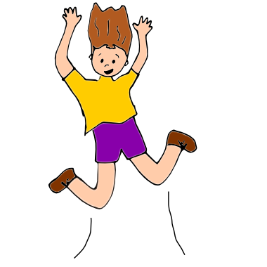

**kwaskoti**

**kwaah-skoo-tay**

**jump**



**manisa**

**muh-niy-sha**

**cut**



**minikwē**

**miy-niy-kweey**

**drink**



**nikamo**

**niy-kuh-muh**

**sing**

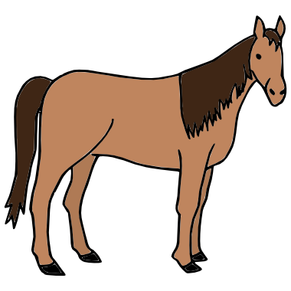

**misatim**

**miss-uh-tim**

**horse**

**Created for MLCN Urban Services**

**Developed by: Steven Swan**