nēhiyāw masināhikan

Cree Language Booklet

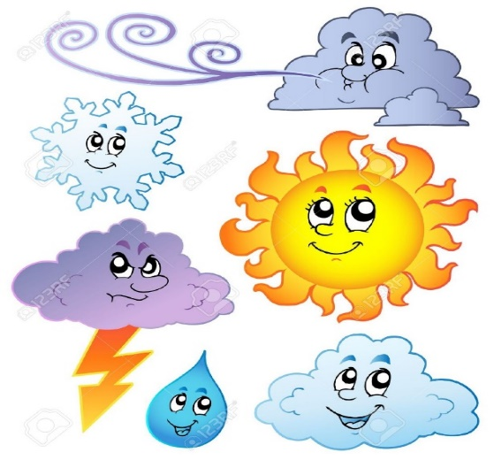

Unit 7

Weather and Actions

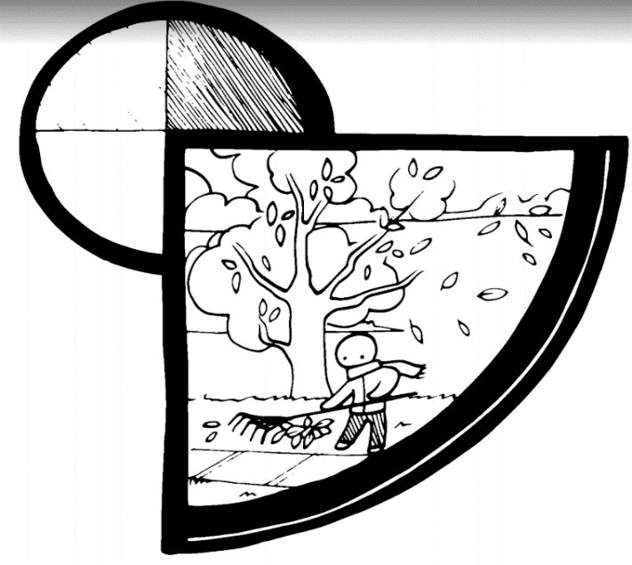

**takwākin**

**ta-kwaa-gin**

**fall**

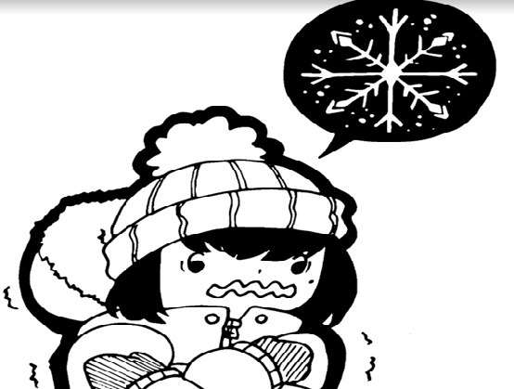

**tahkāyaw**

**taa-kaah-yaw**

**cold**

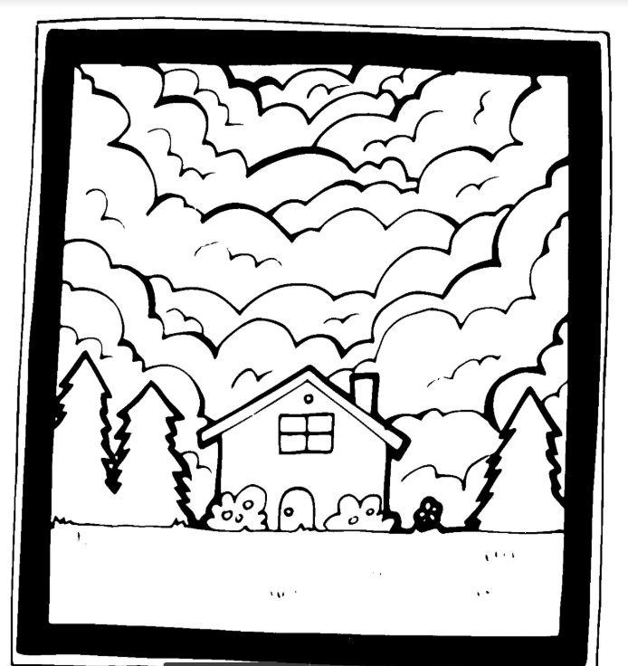

**yīkwaskwan**

**yee-kwah–skwan**

**cloudy**

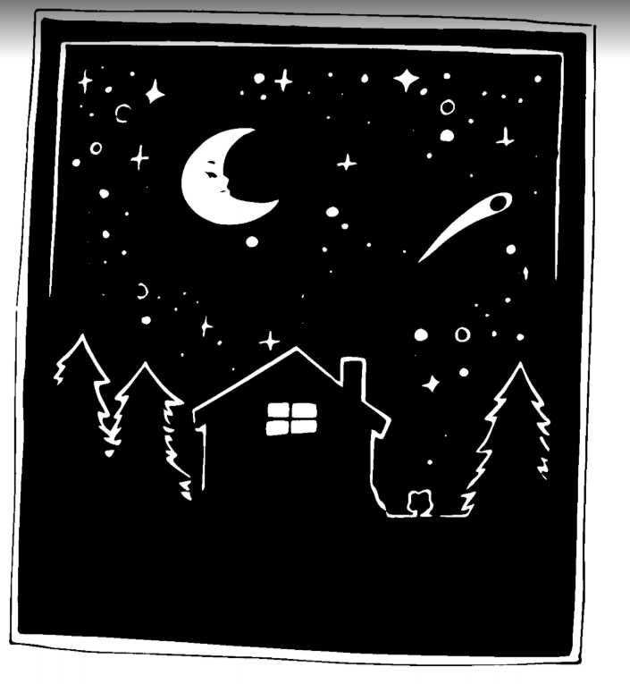

**tipiskāw**

**tip-is-cow**

**Night time**

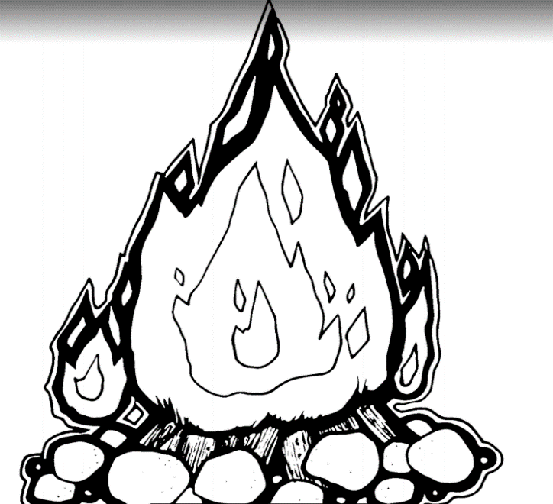

**iskotēw**

**is-koh-teew**

**Fire**

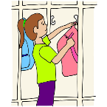

**akota**

**ah - ko - tuh**

**Hang up**

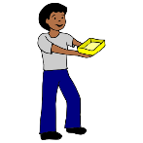

**tahkona**

**tah-koh-nah**

**Carry it**

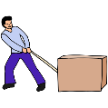

**ochipita**

**oh-chi-pe-tah**

**Pull**

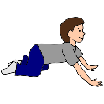

**pimitācimo**

**pe-meh-taah-chi-mu**

**Crawl**

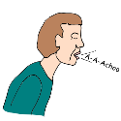

**cāhcāmo**

**chaa-chaa-mu**

**sneeze**

**Created for MLCN Urban Services**

**Developed by: Steven Swan**