nēhiyāw masināhikan

Cree Language Booklet

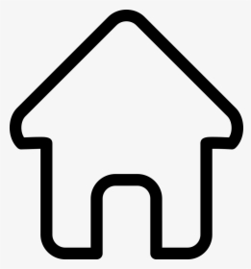

Unit 4

Objects (Home)

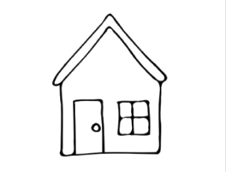

**wāskahikan**

**wash-kay-hiy-gun**

**House**

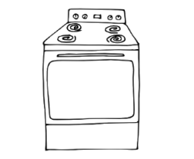

**kotawānāpisk**

**koo-tuh-waah-naah-pisk**

**stove**

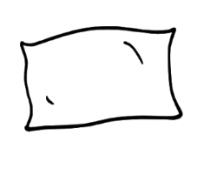

**aspiskwēsimon**

**ash-piy-skwey-shi-muhn**

**Pillow**

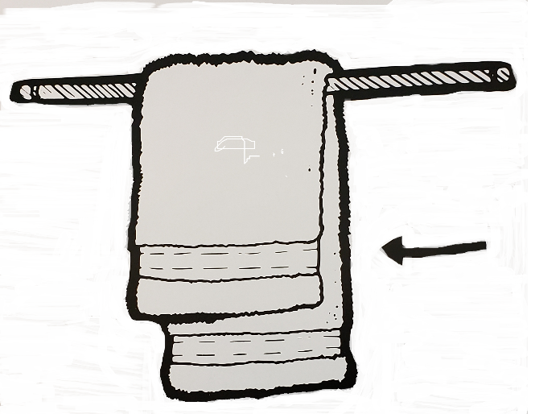

**pāhkohkwēhon**

**paah-koh-kweey-huun**

**Towel**

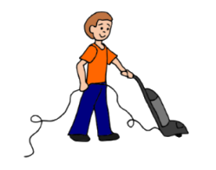

**kanācihcike**

**kah-naah-chi-chi-key**

**clean up**

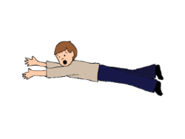

**pimisini**

**piy-miy-siy-niy**

**lay down**

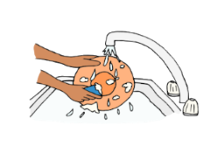

**kasiyakane**

**kah-see-yah-kun-nay**

**wash dishes**

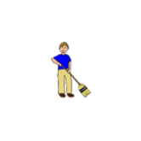

**wepahike**

**way-pie-hi-kay**

**sweep**

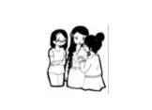

**iskwēwak**

**is-kway-wuk**

**women**

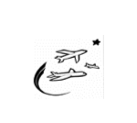

**pimihākana**

**piy-miy-haah-kun-nuh**

**airplanes**

**Created for MLCN Urban Services**

**Developed by: Steven Swan**