nēhiyāw masināhikan

Cree Language Booklet

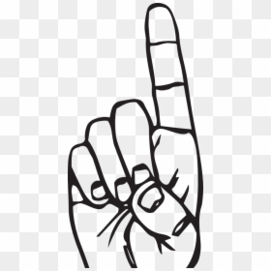

**Unit 2**

**Actions/Identity**



**pāhpi**

**paah-piy**

**Laugh**



**māto**

**maah-two**

**Cry**

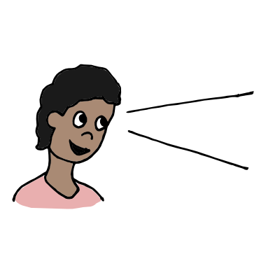

**kitāpahta**

**kiy-taah-pah-tah**

**Look**

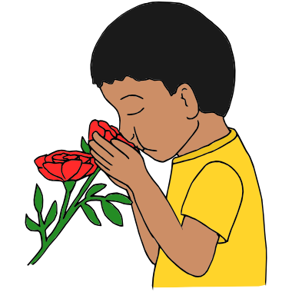

**miyāhta**

**me-yaah-tah**

**Smell**

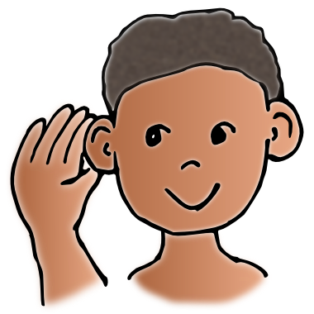

**nitohta**

**nih-two-tuh**

**Listen**

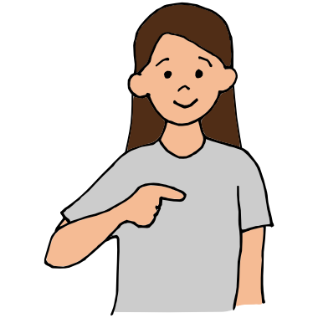

**nīya**

**knee-yah**

**Me**

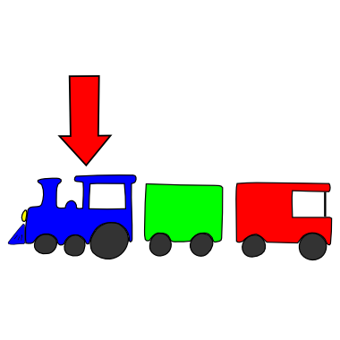

**nīkān**

**knee-can**

**Front**

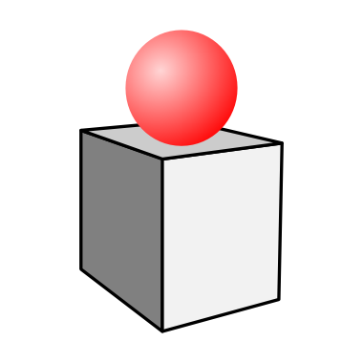

**tākohc**

**taah-kooch**

**Top**

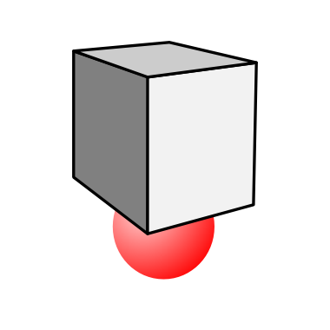

**sēpāk**

**say-paack**

**Under**

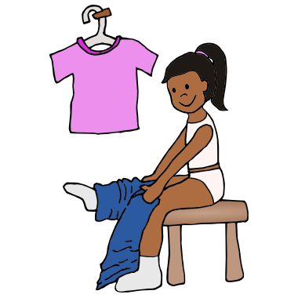

**postāywinsē**

**push-taay-win-see**

**get dressed**

**Created for MLCN Urban Services**

**Developed by: Steven Swan**