nēhiyāw masināhikan

Cree Language Booklet

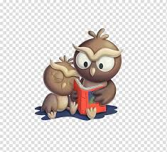

Unit 5

Actions, Animals and Every Day Items

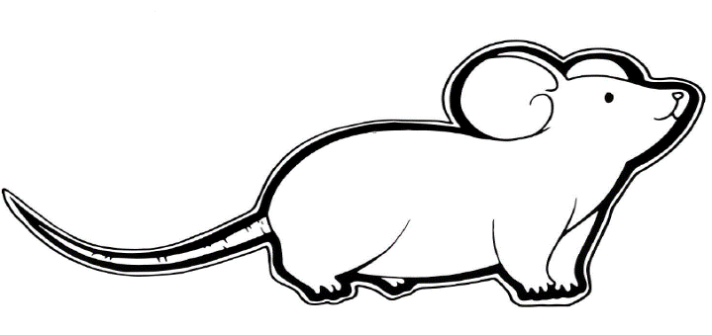

**wāpakosīs**

**waah-puck-oh-sees**

**Mouse**

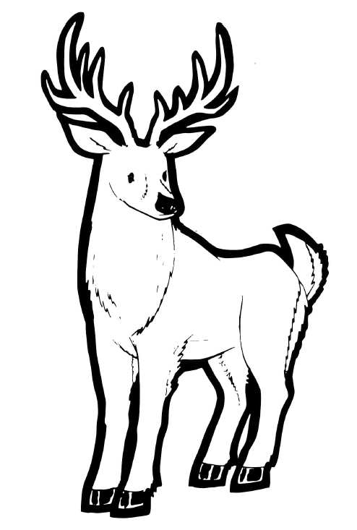

**apisimōsos**

**ah-piy-siy-moo-sush**

**deer**



**ohtēna**

**oh-tea-nah**

**Open**

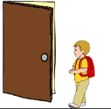

**wayawī**

**way-yah-we**

**go outside**

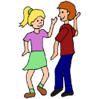

**nīmihito**

**knee-me-two**

**dance**

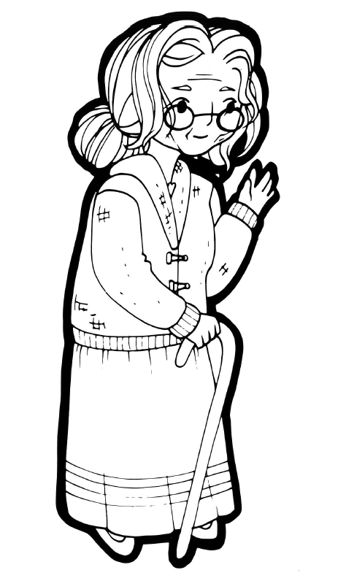

**nōtokwēw**

**nuu-to-ghew**

**Old lady**

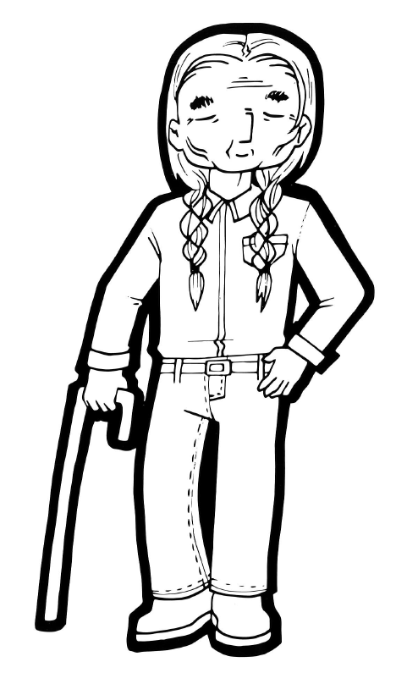

**kiseyiniw**

**kissy-yeh-new**

**Old man**

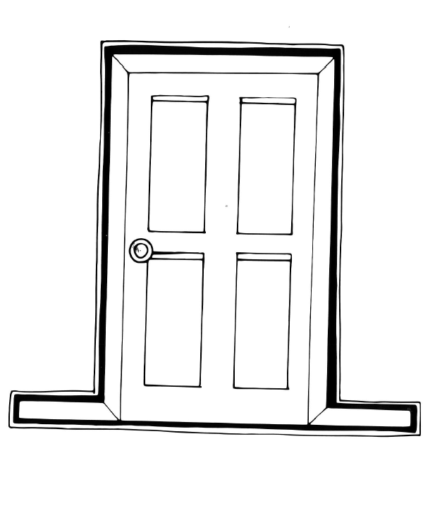

**iskwāhtēm**

**is-kwaah-team**

**door**

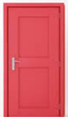

**kipaha**

**kiy-pah-hah**

**Close**

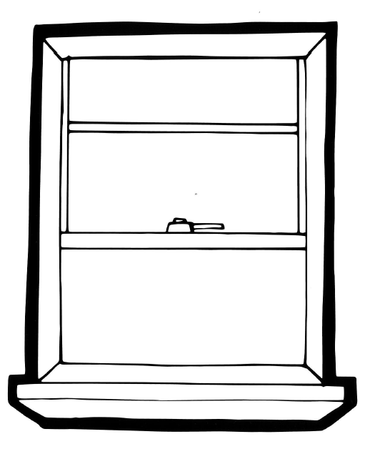

**wāsēnamawin**

**waah-see-nah-mah-win**

**door**

**Created for MLCN Urban Services**

**Developed by: Steven Swan**