nēhiyāw masināhikan

Cree Language Booklet

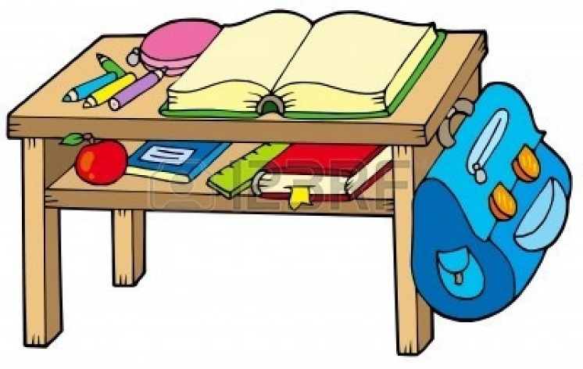

Unit 1

Objects

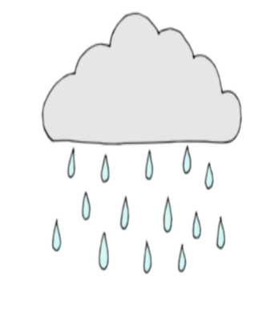

**kimiwan**

**kim-meh-one**

**Rain**

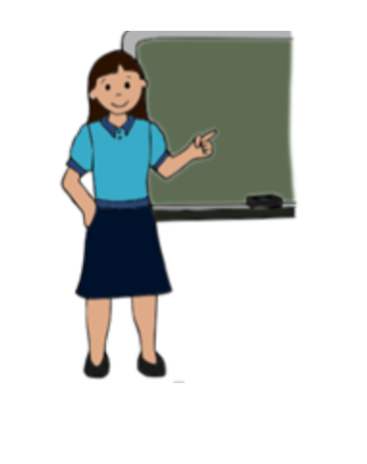

**okiskinōhamākēw**

**oh-kiss-kiy-noo-haa-maa-ghew**

**Teacher**

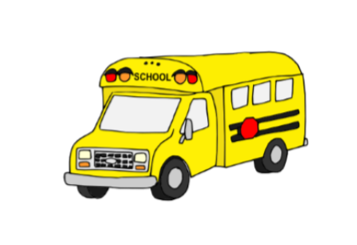

**āwatawāsiswakan**

**aah-wuh-tuh-waah-sis-waa-gun**

**School bus**

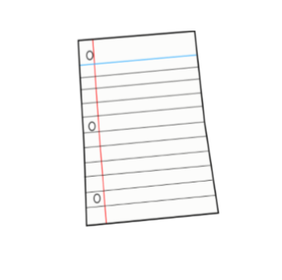

**masinahikanēkan**

**mah-shi-nuh-hiy-gun-knee-gun**

**Paper**

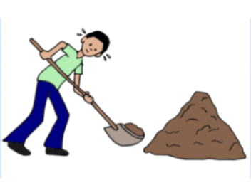

**atoskē**

**uh-two-ski**

**Work**

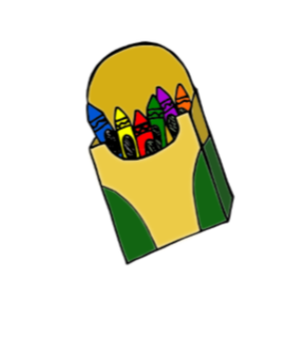

**masinahīkanatik**

**muh-shi-nah-hee-guh-naah-tick**

**crayon/pencil**

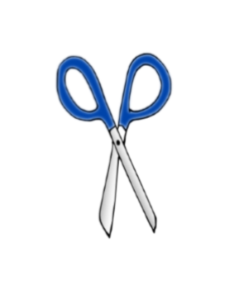

**paskwāhamātowin**

**puss-kwaah-hah-maah-two-win**

**Scissors**

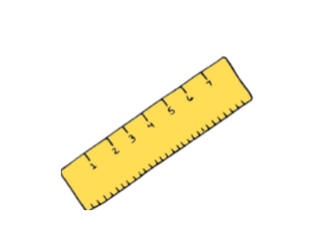

**tipāhikanātik**

**tih-paa-hiy-gun-naah-tick**

**Ruler**

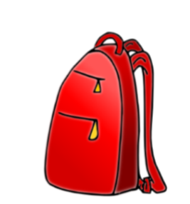

**maskimwat**

**muss-kim-what**

**Backpack**

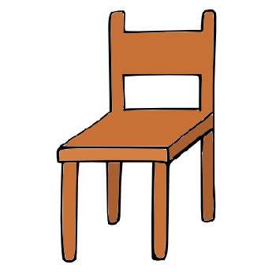

**tītapiwin**

**tee-tuh-piy-win**

**Chair**

**Created for MLCN Urban Services**

**Developed by: Steven Swan**